Installation from Flashdrive
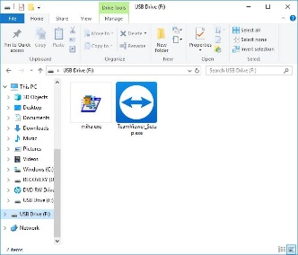
From flashdrive, click the miha.exe icon.
It will unzip the files to your c drive.
once finished go to your C Drive and open the MIHA.temp file
and click installtracker.exe. It will prompt you to run it as an administrator--(right click it and click run as administrator)
You will be prompted to put in your district number, it then goes through a bunch of installation of files and will prompt you to click cancel when finished.
Running the Program
C drive and you will see a normal MIHA folder
D click this folder and open districttracker.exe from here.
DO NOT try to run district tracker from the miha.temp folder. It will not work.
You can also R click on it and create a shortcut to click and drag to your desktop. The program will tell you to set up your first meet. Click ok. This screen will appear
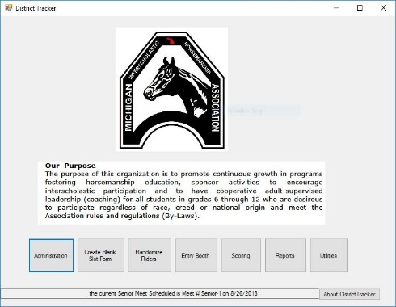
Click administration to set up your meet
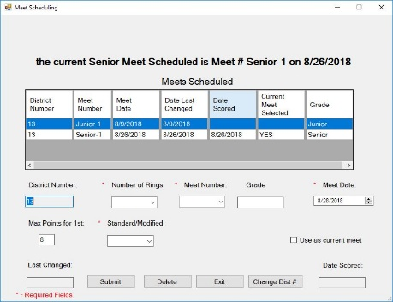
Do NOT change the district number, if the wrong number appears, back out of the program and reinstall.
If you run your meets with each division only showing against itself, A’s only show against A’s etc, then you will want to use 4 rings. You’ll see why later.
If everyone rides against each other, then you can run a single ring.
Make sure to check the use this as current meet box for the meet you want to use.
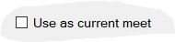
NOTE: Once you have scored a meet you cannot go back to the administration booth and change it, you will get a message that the database has been damaged. At the prompt telling you this, click ok, (in the new version) in the old version( the one on the flashdrives, click YES)
You can tell if you have scored a meet at the administration screen

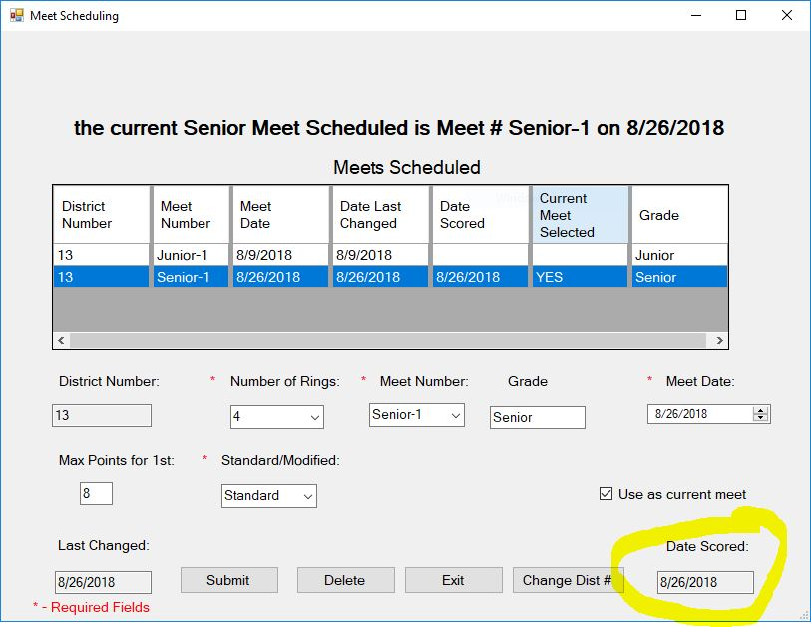

If you enter multiple meet dates at once, make sure that you click the one you want to work with as the current meet and click submit. Check to make sure that it says Yes under current meet then click Exit.

Entering Teams, Coaches, and Riders
Click the button for add a team and proceed to add all of your teams. The program automatically generates a junior team of the same name. Do not worry about that. If you don’t have that junior team, you can delete it later. To see only the Senior teams, click Senior 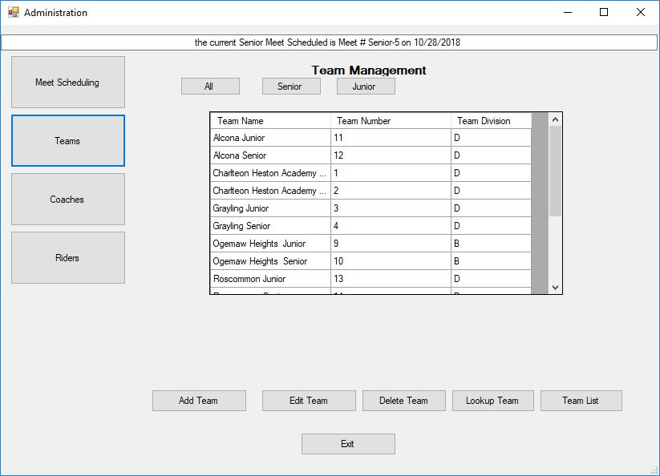
Once you are done entering teams, click Exit

Go back to Administration and click Coaches, add you coaches. When finished, click Exit
Go back to Administration and Click Riders. Add you riders. Be careful to make sure that you assign them to the correct team. Here is a good place to select Senior at the top of the screen; only Senior Teams show up.

Once you are finished, you are ready to enter classes in the Entry Booth.
Entry Booth
You will get this prompt the first time you enter the entry booth for this meet.
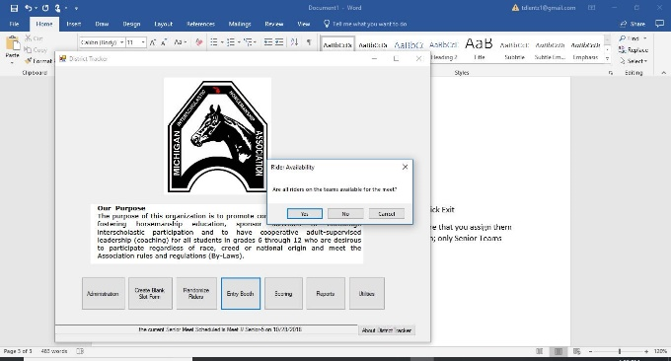

If all members are present, simply click yes. If not, click No and you will see this screen.
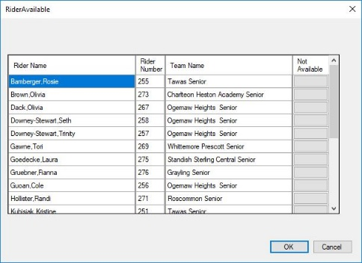
NOTE On all these screens you can change the view simply by clicking the heading and it will order your riders accordingly. If you want to see them by number order, click on the number heading label and they will show up in numerical order. If you click on teams, they will show up by team in alphabetical order.
Once you click the OK button, you are ready to entry your riders. This is where the number of rings comes into play. If you run the meet with A’s competing only against A’s etc. you need to assign the teams to the rings on this screen. The easiest way is to click on the Division heading which will arrange the teams by division, then click in the ring number and type in the ring number.
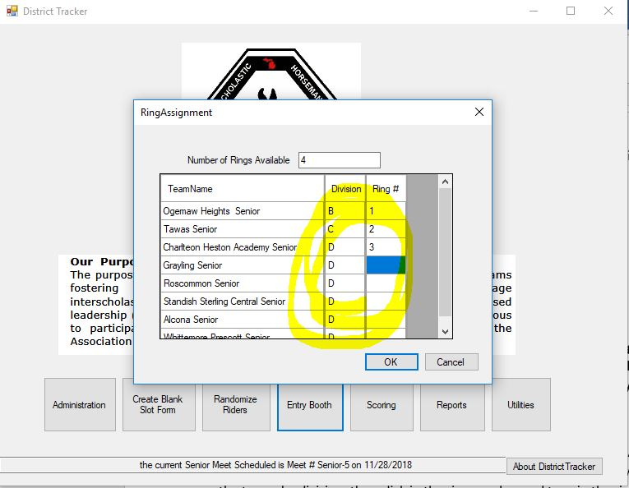
TO LOAD THE MOST UPDATED TRACKER
Go to the MIHA folder on your computer. Find the districttracker.exe file . rename it to districttrackerold.exe. Now copy the new dstricttracker.exe file from the flashdrive or other source, and copy it into the MIHA folder on your PC. Now open it and your old data will automatically be in there.

If you have any issues with this, give me a call and I can help you out. 989-254-7824

